HMMs

Introduction
As mentioned earlier, ASR problem can be attacked from two sides; namely
- From the side of speech generation
- From the side of speech perception
The Hidden Markov Model(HMM) is a result of the attempt to model the speech generation statistically, and thus belongs to the first category above. During the past several years it has become the most successful speech model used in ASR. The main reason for this success is it's wonderful ability to characterize the speech signal in a mathematically tractable way.
In a typical HMM based ASR system,the HMM stage is proceeded by the preprocessing (parameter extraction) stages. Thus the input to the HMM is a discrete time sequence of parameter vectors, such as those described in the previous chapter. The parameter vectors can be supplied to the HMM, either in vector quantized form or in raw continuous form. It can be designed HMMs to handle any of the cases, but important point is how the HMM deals with the stochastic nature of the amplitudes of the feature vectors which is superimposed on the time stochasticity.

Definition of Hidden Markov Model
The Hidden Markov Model is a finite set of states, each of which is associated with a (generally multidimensional) probability distribution []. Transitions among the states are governed by a set of probabilities called transition probabilities. In a particular state an outcome or observation can be generated, according to the associated probability distribution. It is only the outcome, not the state visible to an external observer and therefore states are ``hidden'' to the outside; hence the name Hidden Markov Model.
In order to define an HMM completely, following elements are needed.
- The number of states of the model, N.
- The number of observation symbols in the alphabet, M. If the observations are continuous then M is infinite.
- A set of state transition probabilities .
where denotes the current state.
Transition probabilities should satisfy the normal stochastic constraints,
and
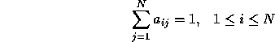
- A probability distribution in each of the states, .
where denotes the observation symbol in the alphabet, and the current parameter vector.
Following stochastic constraints must be satisfied.
and
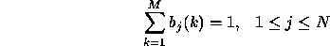
If the observations are continuous then we will have to use a continuous probability density function, instead of a set of discrete probabilities. In this case we specify the parameters of the probability density function. Usually the probability density is approximated by a weighted sum of M Gaussian distributions ,
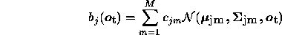
where,
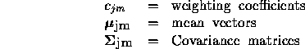
should satisfy the stochastic constrains,
and
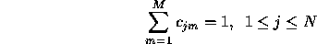
- The initial state distribution, .
where,
Therefore we can use the compact notation
to denote an HMM with discrete probability distributions, while
to denote one with continuous densities. .

